NET Framework

CLR Common Language Runtime

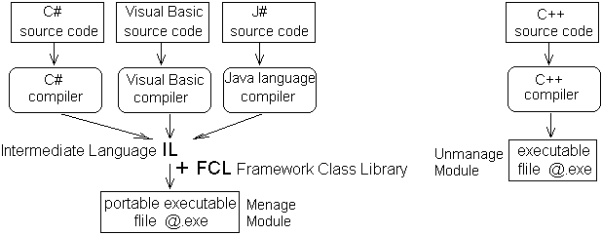

CTS Common Type System

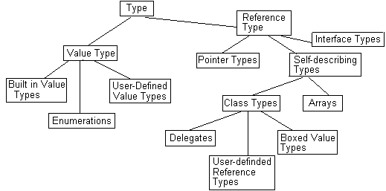

Type | Meaning
Type | Base class that represents any type.
Value Type | Base class that represents any value type
Reference Types | Any data types that are accessed through a reference and  stored on the heap
Built-in Value Types | Includes most of the standard primitive types, which represent  numbers, Boolean values, or characters.
Enumerations | Sets of enumerated values.
User-defined Value Types | Types that have been defined in source code and are stored  as value types. In C# terms, this means any struct.
Interface Types | Interfaces
Pointer Types | Pointers
Self-describing Types | Data types that provide information about themselves for  the benefit of the garbage collector
Arrays | Any type that contains an array of objects
Class Types | Types that are self-describing but are not arrays
Delegates | Types that are designed to hold references to methods
User-defined Reference Types | Types that have been defined in source code and are stored  as reference types. In C# terms, this means any class.
Boxed Value Types | A value type that is temporarily wrapped in a reference so  that it can be stored on the heap

Windows contains a next versions of .NET Framework by default
XP
• .NET v1.0 -- Service pack 1
• .NET v2.0 -- Service packs 2 & 3
Vista
• .NET v3.0 -- All service packs
Windows 7
• .NET v3.5 -- All versions and service packs
Windows 8
• .NET v4.0 + Metro UI available.
Windows 8.1
• .Net v4.5 + Metro UI available.
Windows 10
• .Net v4.6 + Metro UI + Universal Apps available.
Note:
All contains .NET v4.6 if Windows Update is enabled. (Not for all versions of windows)

